**Euclidean Algorithm for Greatest Common Divisor (GCD)**

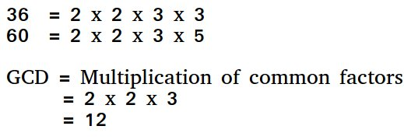

Given two non-negative integers aa and bb, we have to find their **GCD** (greatest common divisor), i.e. the largest number which is a divisor of both aa and bb. It's commonly denoted by gcd(a,b). Mathematically it is defined as:

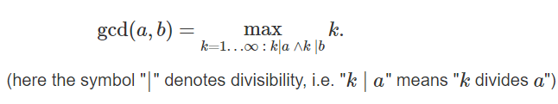

When one of the numbers is zero, while the other is non-zero, their greatest common divisor, by definition, is the second number. When both numbers are zero, their greatest common divisor is undefined (it can be any arbitrarily large number), but we can define it to be zero. Which gives us a simple rule: if one of the numbers is zero, the greatest common divisor is the other number.

The Euclidean algorithm, discussed below, allows to find the greatest common divisor of two numbers aa and bb in O(log min(a,b)) .

The algorithm was first described in Euclid's "Elements" (circa 300 BC), but it is possible that the algorithm has even earlier origins.

## **Algorithm**

The algorithm is extremely simple:

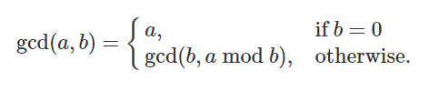

Pseudo Code of the Algorithm-

**Step 1:  Let  a, b  be the two numbers  
Step 2:  a mod b = R  
Step 3:  Let  a = b  and  b = R  
Step 4:  Repeat Steps 2 and 3 until  a mod b  is greater than 0  
Step 5:  GCD = b  
Step 6: Finish**

**RELEVANT READING MATERIAL AND REFERENCES:**

**Source Notes:**

1. <https://www.freecodecamp.org/news/euclidian-gcd-algorithm-greatest-common-divisor/>
2. <https://cp-algorithms.com/algebra/euclid-algorithm.html>

**Lecture Video:**

1. https://youtu.be/VWOUh4w_zVI

**Online Notes:**

1. <http://vssut.ac.in/lecture_notes/lecture1428551222.pdf>

**Text Book Reading:**

1. Cormen, Leiserson, Rivest, Stein, “*Introduction to Algorithms*”, Prentice Hall of India, 3rd edition 2012. problem, Graph coloring.

**In addition: PPT can be also be given.**